Dynamic Beam Management for NR using Adaptive Antenna Array

Adti Singh   
Department of Electrical EngineeringIndian Institute of Technology Kharagpur, India Email:aditisingh9@iitkgp.ac.in

*Abstract*—Frequency range between 300 MHz – 3 Ghz is considered the “sweet spot” for communication and has reached its theoretical limits of time and frequency resource utilization. In order to serve the increasing demand, the utilization of millimeter-waves (mm-wave) attributed to frequency range of 30 Ghz – 300 Ghz is crucial. The use of mm-wave is challenging pertaining to hardware inefficiencies, high penetration loss, scattering, high cost of RF and signal processing components. In order to deal with the losses, directional beam-based communication is used instead of omnidirectional communication. The radiation energy of signal is concentrated in specific directions instead of being wasted in all directions. This establishes a mandate for sophisticated beam management mechanisms for the formation of the directional beams. In this paper we utilize adaptive antenna array in association with hybrid beamforming techniques to propose an initial access procedure (IAP) for NR transmission abiding by the 3GPP standards and a novel beam tracking algorithm to cope with node mobility with minimum handover and overhead cost.

Keywords—beamforming, antenna, array, NR, beam tracking, 3GPP

# Introduction (*Heading 1*)

The next generation of communication-5G NR is expected to satisfy the increasing data traffic by utilizing the higher spectrum band which is much less crowded than the present band and allows for smaller component size. It uses mm-waves whose performance is limited by its low penetration distance, scattering by atmospheric gases and expensive components. The solution involves using an antenna array coupled with hybrid beamforming techniques to form directed beams for communication between the Base Station (gNB) and User Equipment (UE).

Beam management techniques are important for effective employment of directed beams. In case of low / mid frequency operating conditions, a single omnidirectional transmission would suffice for communication between gNB and UE. However, for beam shaped radiations the complexity of procedure for establishing initial contact between the UE and gNB increases multifold. Another important facet is to maintain contact in case of moving UE. IAP is a time-consuming process yet it cannot be eliminated in Standalone NR based communication. Maintaining communication in dynamic conditions is of utmost importance as it deals with moving UEs which is often the case in practical scenarios - for example communication has to be maintained for a person walking or in a car. Most of the methods proposed for beam tracking perform a repeated IAP whenever the signal quality reduces below a certain threshold which results in wastage of time and network resources. Thus, an effective IAP as well as beam tracking in conjunction with techniques which ensure noise and interference free communication is the need of the hour.

For beam formation, an array of antennas is utilized so that their cumulative gain compensates for the low penetration and scattering of mm-wave. The governing principle of an antenna array is to have constructive interference in the desired direction of the beam and destructive interference in the other interfering directions. The desired radiation pattern of the antenna array constitutes of a narrow main lobe and absence of any grating lobes. In reality we thrive to be as close to ideality as possible. This technique of spatial filtering is referred to as beamforming. Beamforming can be broadly classified into Analog beamforming, Digital beamforming and Hybrid beamforming. Digital beamforming is unsuitable for mm-wave based communication due to high cost and power consumption and analog beamforming has poor performance. In order to reduce costs but still get optimum results hybrid beamforming is the key. It uses digital beamforming in the azimuthal plane and analog beamforming in the elevation plane.

In this paper we consider a stationary gNB and a moving UE both of which are equipped with adaptive antenna arrays and hybrid beamforming techniques for producing directed beams. Frequency Division Duplexing (FDD) is employed for uplink (UL) and downlink (DL) communication to occur simultaneously. Adaptive antenna array is capable of altering its radiation pattern in accordance with the changing environment. Our motive is to maintain continuous end to end communication between gNB and UE at all times. This objective is broadly classified into two phases being Phase 1 - IAP for the gNB – UE pair which is in accordance with the 3GPP TS 38.802-6.1.6.1 version 14.2.0 Release 14 and a Phase 2 - Beam tracking procedure for moving UE. The principal contributions of this paper are as follows:

* We have established an efficient IAP which guarantees initial communication between gNB and UE. It is in accordance with the 3GPP TS 38.802 Version 14.2.0 Release 14. It utilizes the Primary Synchronization Signal (NR-PSS) and Secondary Synchronization Signal (NR-SSS) coupled with at least one broadcast channel (NR-PBCH) all of which are transmitted within a Synchronization Signal Block (SSB) for synchronization. The Physical Random Access Channel (PRACH) associated with each downlink SSB block is used by the UE for providing feedback to the gNB.
* An effective Direction of Arrival (DOA) estimation algorithm is introduced which is essential for beamforming. It is an extension of the state of the art Multiple Signal Classification (MUSIC) algorithm. MUSIC algorithm needs prior knowledge of the number of sources for DOA estimation. Our algorithm does not have this limitation and thus increases the capabilities of the MUSIC algorithm and adapts it to suit to our needs.
* We propose a novel beam tracking procedure based on Stop-Wait-CatchUp control algorithm which minimizes the number of handovers and overhead ensuring that the communication link between gNB and UE is maintained without the requirement of repeated IAP or dedicated extra resources.
* In wireless communication, multipath propagation is the phenomenon that results in radio signals reaching the receiving antenna by two or more paths. Causes of multipath include atmospheric ducting, ionospheric reflection and refraction, and reflection from water bodies and terrestrial objects such as mountains and buildings. This phenomenon forces the receiver to conceive a single source as multiple sources which can result in problems for deciding weights in case of directional beam-based communication. We consider and successfully address this phenomenon.

MATLAB based simulation indicates success of the IAP as well as the Stop-Wait-CatchUp control algorithm for beam tracking.

# Related Work

There is replete literature present on the various beamforming techniques for adaptive array antennas. The need of beamforming techniques is illustrated in [1] which showcases the challenges in mm-wave communication. [2] proposes a least mean square method for determining the weights of a phased array but its efficiency is limited. In [3] conventional MUSIC algorithm is implemented using MATLAB limited by the prior knowledge of number of sources.

Work in the domain of IAP includes numerous techniques. A recursive neural net-based procedure which relies on validity of previously obtained information is used for IAP in [8] for narrowing the search range. In [9] the authors analyze an iterative and exhaustive search across the whole angular domain irrespective for UE position with limited number of wideband beams being formed by the UE in the absence of DOA estimation. A two-phase procedure for deciding the precoder for initial access is developed in [10].

According to the knowledge of the authors, very few resources address the issue of dynamic beam management for moving UE. [11] gives a probabilistic strategy to achieve the objective of beam tracking with node mobility without dedicated synchronization signals. The UE designates weight values which maximize the probability of reference signal being in a particular direction. An algorithm for beam re-establishment of link under mobility is proposed in [12] which uses past traffic data for efficient beam tracking with reduced overhead. This algorithm does not work well for non-line of sight communication in complex and dynamic environments. In [13] a methodology for identifying error due to UE mobility is put forward however no beam tracking algorithm is proposed to prevent this error.

The propagation characteristics of indoor and outdoor environments using methods like ray tracing [14] and in urban environments using multidimensional measurement and advances ray tracing simulations [16] provides justified reasons for multipath propagation. It is an unavoidable reality and has to addressed. However, at mm-wave frequencies only line of sight path and a few dominant multipath components contribute to the received power as the received power of diffused scattering and multiple-bounce specular reflections is miniscule. For estimating the direction of arrival in the presence of multipath propagation [15] proposes a three-stage numerical estimation technique.

Finally, it is worth mentioning that none of the previous work tackles the accumulative challenge of maintaining end to end NR communication between UE and gNB in all practically occurring situations.

# System Implementation

Beam management is a crucial aspect of directed beam based communication. It enables uplink and downlink communication between UE and gNB in the absence of omnidirectional beams. As soon as the UE turns on it is initially in the IDLE state. It subsequently enters into the CONNECTED state and connects with the gNB after which data transfer can take place. For instigating the connection, gNB transmits a special synchronization signal which should be able to reach the UE. This results in a serious problem if the gNB is sending signals in the form of a directed beam which cannot cover a wide area at a particular instant of time. Thus, the gNB needs to figure out where it needs to point its beam. Our proposed IAP deals with this very aspect. The succeeding task is to maintain the communication for moving UE which is dealt by Stop-Wait-CatchUp control algorithm for beam tracking. We will deal with both these aspects in Phase 1 and Phase 2 respectively.

1. *Phase 1 – Initial Access Procedure*

According to the 3GPP TS 38.802-6.1.6.1 version 14.2.0 Release 14 the IAP for downlink beam management is composed of three parts P1/P2/P3.

P1. Beam Selection

P2. Beam Refinement for Transmitter (gNB Tx)

P3. Beam Refinement for Receiver (UE Rx)

Our proposed algorithm implements these three parts so as to establish initial connection between a single gNB – UE pair. The gNB is equipped with an NgNB x NgNB antenna array matrix and is further divided into N subarrays such that *n* <= NgNB – each column is a subarray for n columns- for hybrid beamforming. The UE is equipped with a 1 x NUE antenna array with NUE subarrays for hybrid beamforming. Beamforming in azimuthal plane has been implemented using digital beamforming such that each subarray has the same spatial filter thus needing only *n* RF chains and T/R modules. It can straightforwardly be extended to the elevation plane by including analog beamforming to induce further phase shifts among the subarray antennas. The algorithm is as follows:

*P1. Beam Selection*

In this part the gNB sweeps its DL beam across the angular domain till it locates the UE. The initial weights of each UE antenna is unity which implies that it is impartial with respect to direction of beam. Spatial filtering for DL communication at the gNB is achieved by allocating appropriate complex weights to the subarrays. The signal at each antenna is multiplied with its corresponding weight and the final signal transmitted is the vector sum of all these altered signals as illustrated in equation (7). The essence of digital beamforming is forming a directed beam by allocating appropriate complex weights.

The specific digital beamforming technique used by gNB is *phased array-based weight estimation* algorithm. It is governed by the principle wherein weights are chosen such that they cancel out the phase difference at the subarrays due to the propagation of the wave as illustrated by equations (5) and (6). On account of the fact that one column of the antenna array constitutes a subarray with each antenna of the array column being allocated the same weight, we consider that each row is a 1 x *n* array with *n* antennas. Therefore, the gNB array matrix is composed of *n* such identical rows. Beamforming for one row can be identically extended to all the other rows. Each row is aligned parallel to the x axis and the antennas are separated by a distance *d*. Their positions are given by:

For *n < NgNB*

T  (1)

The set of phase delays experienced by a plane wave evaluated at the array antennas is represented by $\vec{Vn}$ which is known as the steering vector. As the mm-wave satisfies the far field narrowband condition its front can be considered as a plane wave having steering vector given by equation (2).

$\vec{Vn}= [\begin{matrix}v(1) & v(2)\end{matrix}…\begin{matrix}v(n-1) & v(n)\end{matrix}]$ (2)

For the beam to be directed at θ and having antennas spaced *d* distance apart:

$$d\left(m\right)=md for m=1,2,….n (3)$$

$$v\left(m\right)=e^{\frac{-i2πdmcos(Θ)}{λ}} for m=1,2,….n (4)$$

$$w\left(m\right)=e^{\frac{i2πdmcos(Θ)}{λ}} for m=1,2,….n (5)$$

$\vec{Wn}= [\begin{matrix}w(1) & w(2)\end{matrix}…\begin{matrix}w(n-1) & w(n)\end{matrix}]$ (6)

Thus the final signal $\vec{S}$ is computed as follows

$\vec{S}=\sum_{m=1}^{n}{\vec{Wn}} \vec{Vn}$ (7)

NR-PSS is utilized as the reference signals for synchronization which along with NR-PBCH and NR-SSS constitute the DL-SSB. Each DL-SSB is indexed in order that the UE is able to identify the angle of the directed beam. According to the 3GPP standard there is a limitation on the number of beams which can be produced by the gNB (*L*). Thus, the entire angular domain can be divided into at most L sectors and DL-SSB index ranges from 0 to *L*-1. The index conveys information about the angle of the peak of the gNB beam for that particular time instant for line of sight communication. Due to symmetry it suffices to consider the angular range of [0, П] as seen by Fig 2(a). This pattern is symmetric about the 0-180 axis.

Since the beams formed are not extremely narrow (n < NgNB), it is justified to assume that line of sight communication between gNB and UE is feasible for at least one beam and that is the one which needs to be selected. This beam is referred to as the line of sight beam (LOSB). But it is also true that due to the beams being not very narrow multipath propagation cannot be ignored and thus we have taken it into consideration. One way to find LOSB is to sweep the entire angular domain and then select the best beam [9] as shown in Fig 2(a). But this approach is inefficient and time consuming. What we propose instead is to stop the sweeping once the LOSB has been found. Considering multipath propagation, it is likely that the first gNB beam which reaches the UE may not be the LOSB as depicted in the Fig 1 where the first beam to be received by the receiver (UE) is the Reflection beam while the LOSB beam is the Direct beam. To verify whether the received beam is LOSB or not, UE compares the DL-SSB index and the DOA peaks found by the *Improved MUSIC* algorithm which upon matching even once indicates that the LOSB has been found and sweeping can be stopped as shown in Fig 2(b). Till the final beam has been selected, the weights of the UE antenna array remain unity. The *Improved MUSIC* algorithm is described at the end of this section to maintain continuity.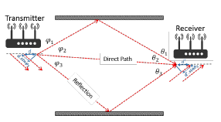

Fig 1. Reflection of gNB beam to reach UE.

Once the LOSB has been detected the UE sends an acknowledgment to the gNB. Using the SSB index, the UE adjusts its weights with the aid of the phased array-based weight estimation algorithm to form the directed beam for UL communication. The gNB receives the acknowledgement by utilizing the DL-SSB index to estimate the UE angle and adjusting its weights accordingly. Each DL-SSB is associated with UL-PRACH resource which is wielded by the UE for UL communication. It informs the gNB about the achievement of synchronization by utilizing a specific Boolean UL-PRACH resource which is FALSE in case of non-LOSB reception or no reception at all at UE. On receiving TRUE as feedback, the gNB launches the Radio Resource Control (RRC) protocol which is followed by RRC connection setup request by UE embarking the end of beam selection part.

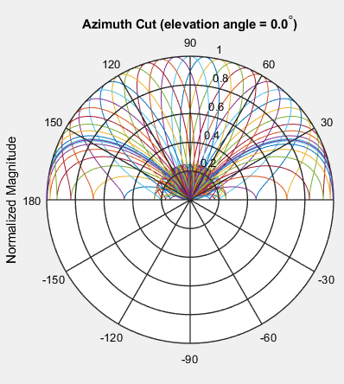

Fig 2(a). Beam sweeping by gNB over whole half angular domain where different colors represent different time instants. *L* = 30

Fig 2(b). Beam sweeping by gNB for UE located at 1000(left) and 600(right), different colors denote different time instants. 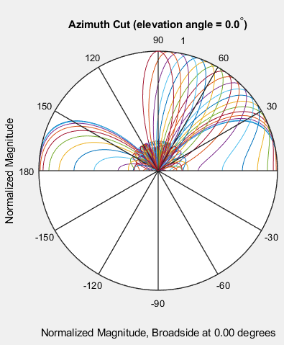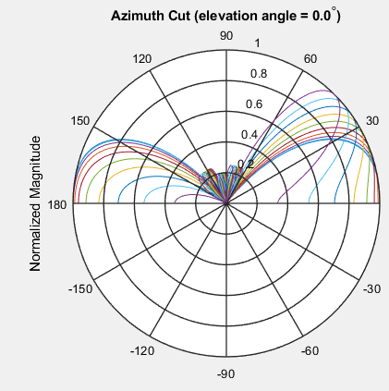

*P2. Beam Refinement for Transmitter*

Once the RRC connection setup is concluded a dedicated DL-SSB and UL-PRCH is no longer transmitted. Beam selection enables the UE to select the rudimentary DL beam but not the optimal beam. P2 handles the act of choosing the premier DL beam between UE and gNB by sweeping narrower beams in a narrower range. We advocate that the gNB forms beams for an additional ten degrees in the clockwise direction moving one degree per iteration with *n* = NgNB thus producing the narrowest possible beam. It is justified to ignore multipath propagation for such narrow beams. Throughout P2 gNB transmits the DL Channel State Information (DL-CSI) signal which is used as the reference signal by the UE for the calculation of UL Reference Signal Received Power (UL-RSRP). This UL-RSRP value serves as the acknowledgement sent to the gNB by the UE via the UL Sounding Reference Signal (UL-SRS). Both DL-CSI and UL-SRS have the same index to specify the beam identity and consequently the angle of the gNB beam for which RSRP has been calculated. It enables receipt/transmission of UL-SRS and DL-CSI signals. After completion of sweeping over the narrower range the gNB selects the DL beam having maximum UL-RSRP value as its final directed DL beam and by choosing weights accordingly for UL communication with the assistance of *phased array-based weight estimation* algorithm.

*P3. Beam Refinement for Receiver*

P3 takes place parallel to P2 in the time domain but at the UE end. The DL-CSI index enables DOA estimation at the UE as it provides the angle of the narrower line of sight beams. The UE decides its weights for UL communication using phased array-based weight estimation algorithm and sends the UL-RSRP values of the received DL-CSI reference signal as acknowledgement via the UL-SRS signal along with the same index. The final UE weights are the ones with maximal RSRP value likewise to the gNB. This marks the end of the Phase 1 – Initial Access Procedure. The gNB and UE can now exchange data.

*Improved MUSIC Algorithm*

Improved MUSIC enables pseudo-spatial spectrum construction. The basic idea of MUSIC algorithm is to conduct characteristic decomposition of the covariance matrix of any array output data, resulting in a signal subspace orthogonal with a noise subspace corresponding to the signal components. Then these two orthogonal subspaces are used to constitute a pseudo-spatial spectrum function the spectral peaks of which are used to detect DOA of signal. Its advantages include high resolution, accuracy and stability. It find the angles of the constituent signals which interfered in order to construct the signal given as input to the MUSIC algorithm. The conventional use of MUSIC is in the presence of multiple sources the number of which are known prior to the algorithm implementation. But for our application there is just one source which is being perceived by the receiver, in this case the UE, as multiple sources due to multipath propagation, the number of which are unknown. The non-LOSB beams may reach the UE and even the LOSB beam may be presumed by the UE to come from a number of directions other than the direct path direction. We proceed to appreciate conventional MUSIC algorithm and thereafter move onto the improved version proposed by this paper.

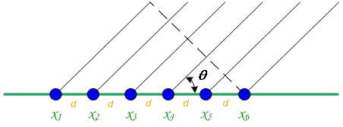

Fig 3. Unifrom Linear Array receiving plane wave at angle θ

MUSIC algorithm is characterized by an array of covariance decomposition. The signal received by the elements of the UE antenna array made up of NUE antennas is represented by a NUE x 1 matrix X. For *n* = NUE

**XT =** T  (8)

For beam being received at an angle θ,

$$x\left(m\right)=e^{\frac{-i2πdmcos(Θ)}{λ}}+AWGN(m) for m=1,2,….n (9)$$

Where *AWGN(m)* is the measurement noise which is considered to be additive white gaussian noise (AWGN). The covariance matrix **Rx** is given by

**Rx** = E[**XXH]** (10)

Where **H** denotes the complex transpose matrix.

In the succeeding step of the conventional MUSIC algorithm we require the number of sources, the need of which is eliminated in the Improved MUSIC proposed in the paper. We iteratively choose the number of sources (*D*) starting form one and culminating when the either *D* exceed the number of peaks in the pseudo spatial spectrum or *D* exceeds NUE. Here the number of sources is the number of different paths observed by the UE for one source – gNB, due to multipath propagation. To calculate the pseudo spatial spectrum the eigen values of RX are sorted in accordance with size where *D* largest eigen values are corresponding to the signal and while NUE-*D* smaller eigen values are corresponding to noise. The eigen vectors are column matrices having dimension NUE x 1. The eigen vectors (**V(i)**) associated with the noise eigen values form the noise matrix **En** given in equation (11).

**En=** ](11)

The pseudo spatial spectrum function (***PPSS(φ)***) is defined by

***PPSS(φ)*** = 1 / **C(ϕ)HEnEnHC(ϕ)** (12)

Where **C(ϕ)** is given by equation (13) and (14).

**C(ϕ)=** ](13)

For a particular value of ϕ,

$$v\left(m\right)=e^{\frac{-i2πdmcos(ϕ)}{λ}} for m=1,2,….n (14)$$

Where φ is varied from zero to П and the estimated DOA value is obtained by searching the peaks of ***PPSS(φ)*** as shown in Fig 4. This whole procedure is repeated till the culminating condition is achieved and the apparent number of sources is *Df* having DOA angle values φ1, φ2 …. ¬φDf. It can estimate at most NUE directions.

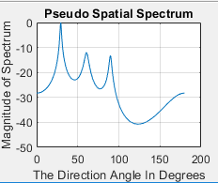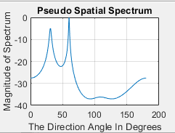

Fig 4 – Pseudo Spatial Spectrum when Incident angles at UE are 300 and 600(*left*); Incident angles at UE are300, 600 and 900 (*right*)

1. *Phase 2 – Beam Tracking*

This phase performs the objective of maintaining the connection between a gNB – UE pair when UE is in motion. The UE is in CONNECTED state which ensures that the gNB is continuously sending DL-CSI reference signal and UE is sending UL-SRS signal and both these signals are successfully received by the latter entity as the gNB - UE beams are synchronized. The algorithm exploits the fact that the UE cannot suddenly jump from one point to another but can only move gradually. Consequently, the Stop-Wait-CatchUp control algorithm sanctions movement of the gNB beam in a gradual manner (DL) so as to catch up with the moving UE. It is a two-step process. The first step is observational in nature whereas the next step is adaptive.

*Step 1 – Waiting*

The UE measure the RSRP value of the DL-CSI reference signal and sends UL-RSRP feedback as a part of the UL-SRS signal. The gNB keeps a check on the feedback value. Once this value goes below a particular threshold, Step 2 is initiated. The value of the threshold is chosen such that it is close to but greater than the lower limit of the UL-RSRP acknowledgment. The lower limit of the UL-RSRP acknowledgment is the least value for which connection between the gNB – UE pair is considered suitable for data transfer. It should be noted that UE weights (DL) and beam direction (UL) as well as the gNB weights (UL), beam direction and width (DL) remains unchanged. As the UE is in motion, it moves away from the peak of the gNB beam and thus the magnitude of received CSI reference signal decreases thus decreasing UL-RSRP about which gNB is notified by sending acknowledgment using the SRS signal.

*Step 2 – Catching Up*

The connection between gNB – UE is close to being unsuitable for data transfer and thus the gNB has to change its beam direction (DL) and the UE needs to adjust its weights so that the best DL connection is reestablished between them. The reciprocal is true for UL. For quicker catching up it is proposed that the beam width of gNB is increased by reducing number of subarrays *n*<NgNB thus producing a wider tracker beam. The gNB steers its beam towards the moving UE and the UE choses weights using the *Null Steering* algorithm following the *Improved MUSIC* algorithm (DL).

The aim is to not only designate weights to the UE which allow for maximum reception of gNB's beam but to also enable almost zero reception of possible signals at other angles thus avoiding any undesired interference due to multipath propagation of the wider tracking beam or addition of noise at the UE. Utilizing the pseudo-spatial spectrum formed by the *Improved MUSIC* algorithm we estimate the number of perceived sources *Df*, UE weights are assigned so as to create the main lobe at the global maximum of pseudo-spatial spectrum at the same time forming nulls at the local maxima (*Df* – 1) which signify undesirable signals which should not be received by the UE. This objective is achieved by the *Null Steering* algorithm.

*Null Steering Algorithm*

It is a simplified algorithm which allocates the weights by solving the matrix equation (15) by *Gaussian Elimination.*

**QW = B** (15)

Where **Q** is a *Df* x NUE matrix, **W** is the NUE x 1 weights matrix which has to be found and **B** is a *Df* x 1 matrix which is formed by the first column of the *Df* x *Df* identity matrix. Using equation (2) and (4),

**Q** = $\begin{matrix}q(1) \\ q(2)\end{matrix}$

$$⋮$$

$$\begin{matrix}q(Df-1) \\ q(Df)\end{matrix}$$

$q\left(i\right)=\left[\begin{matrix}v\left(1\right) & v\left(2\right)\end{matrix}…\begin{matrix}v\left(n-1\right) & v\left(n\right)\end{matrix}\right] for i= 1,2,……,Df (16)$

The final complex weights given to the UE antenna elements j are given by the W (j, 1) as calculated by solving equation (15). The final weights (DL) and directed beam (UL) at UE is thus decided as seen in Fig 5(a) - (c). The weights at gNB for UL is decided in the same way as UE does for DL using Improved MUSIC followed by *Null Steering* algorithm.

The *Improved MUSIC - Null Steering* algorithm combination continues till the UL-RSRP value becomes equal to the initial UL-RSRP value before the UE started moving. The direction of movement of the gNB DL beam starts in the anti-clockwise direction and changes direction if previous UL-RSRP acknowledgement value is greater than current value. The speed of tracking is a function of the computational capabilities of the UE and gNB as well as the beam width of the gNB tracking beam. MATLAB simulations show the success of the Stop-Wait-CatchUp control algorithm for UE moving at a speed comparable to that of an individual who is walking/jogging.

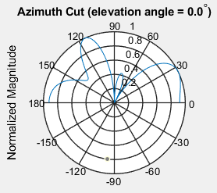

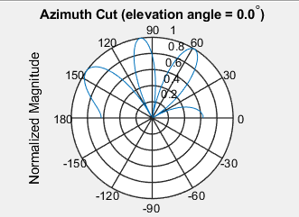Fig 5(a) - UE receives signal at 300, 600 and 900

Fig 5(b) - UE receives signal at 600and 300

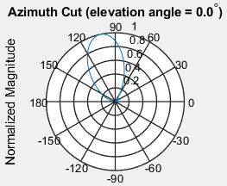

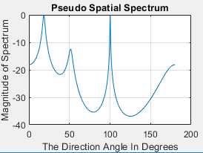Fig 5(c) – UE receives signal at 1000 , 200 and 500.

Although the tracking phase involves moving of the gNB beam and changing of the UE weights and vice versa but it should be noted that at no point the connection between the gNB – UE pair becomes unsuitable for data transfer.

*Results – MATLAB Simulations*

For simulation purpose the UE is considered to move at a speed of 2m/s in a circular path around the gNB at a radius of 200m. The rationale behind these values is that the maximum walking speed of an average human being is around 2m/s and the typical range of mm-wave based communication is 200m. Thus the angular velocity of the UE with respect to the gNB is 0.570 / sec. This compels us to choose the speed of tracking to be greater than 0.570/sec. In the simulation this speed is chosen as 10/sec. The 3GPP standards have not yet specified the standards regarding beam tracking and thus our assumptions do not violate any principle.

As depicted in Fig 6(a.1), the UE is moving in the anticlockwise direction with the above-mentioned speed and the gNB beam is unchanged but the value of UL-RSRP acknowledgment is decreasing as shown in Fig 6(a.2). This is the Step 1 – Waiting.

In Fig 6(b.1), the UE continues moving in the same direction with the same speed but now the gNB beam is also tracking the UE and has started to move in the anticlockwise direction (different colors represent different time instants). The value of the UL-RSRP acknowledgement thus increases as seen in Fig 6(b.2) till gNB beam catches up with the UE and the UL-RSRP value becomes equal to the original value prior to UE’s motion. This is Step 2 – Catching Up.

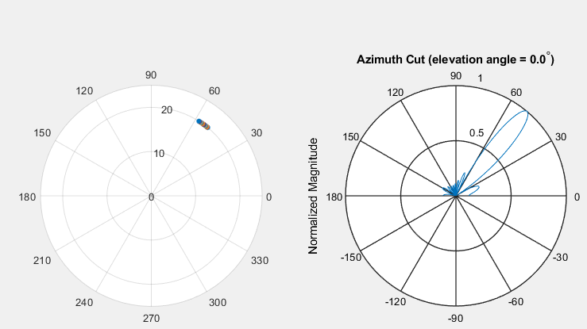

Fig 6(a.1) – UE polar position with gNB at (0, 0) (left)

gNB beam in waiting stage(right)

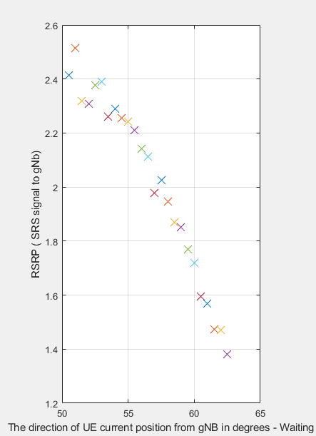

Fig 6(a.2) – RSRP acknowledgement in Waiting stage

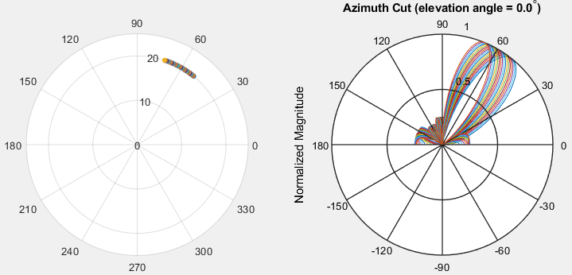

Fig 6(b.1) – UE polar position with gNB at (0, 0) (left)

gNB beam in Catching Up stage(right)

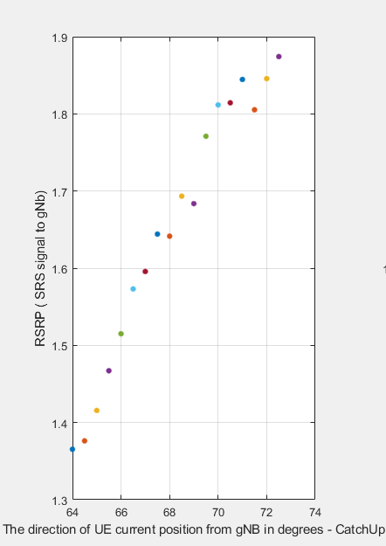

Fig 6(b.2) – RSRP acknowledgement in Catchup Up stage

# Conclusion

. This paper presented analysis and implementation of beam management procedure for initial access and UE in motion using mm-waves. It took into consideration the aspect of multipath propagation at each step so that efficient minimum attenuation communication takes place between the gNB – UE pair. Hybrid beamforming enables DOA estimation followed by pseudo spatial spectrum construction for beamforming at only the crucial stages thus minimizing the need for computational complexity at UE. A new algorithm for beam tracking is proposed which does not disrupt communication at the same time enhances the quality of the communication link using 3GPP defined standard signals thereby accomplishing the objective of maintaining end to end communication between a gNB – UE pair when the UE is in motion. The success of these algorithms is established through MATLAB based simulations.

##### References

1. Niu, Yong & Li, Yong & Jin, Depeng & Su, Li & Vasilakos, Athanasios. (2015). A Survey of Millimeter Wave (mmWave) Communications for 5G: Opportunities and Challenges. Wireless Networks. 21. 10.1007/s11276-015-0942-z.
2. Dwivedi, Vedvyas & Banerjee, Smita. (2013). An LMS adaptive antenna array. INTERNATIONAL JOURNAL OF ADVANCED RESEARCH IN ENGINEERING AND TECHNOLOGY (IJARET). Vol 4. 166-174.
3. <https://pdfs.semanticscholar.org/5ff7/806b44e60d41c21429e1ad2755d72bba41d7.pdf>
4. 3GPP TS 38.802-6.1.6.1 version 14.2.0 Release 14- <https://www.3gpp.org/release-14>
5. <https://www.sharetechnote.com/html/5G/5G_Phy_BeamManagement.html>
6. <http://www.antenna-theory.com/arrays/main.php>
7. <https://www.etsi.org/deliver/etsi_ts/138200_138299/138214/15.02.00_60/ts_138214v150200p.pdf>
8. Mazin, Asim & Elkourdi, Mohamed & Gitlin, Richard. (2018). Accelerating Beam Sweeping in mmWave Standalone 5G New Radios Using Recurrent Neural Networks. 1-4. 10.1109/VTCFall.2018.8690810.
9. M. Giordani, M. Mezzavilla, C. N. Barati, S. Rangan and M. Zorzi, "Comparative analysis of initial access techniques in 5G mmWave cellular networks," 2016 Annual Conference on Information Science and Systems (CISS), Princeton, NJ, 2016, pp. 268-273
10. Desai, Vip & Krzymien, Lukasz & Sartori, Philippe & Xiao, Weimin & Soong, Anthony & Alkhateeb, Ahmed. (2015). Initial beamforming for mmWave communications. Conference Record - Asilomar Conference on Signals, Systems and Computers. 2015. 1926-1930. 10.1109/ACSSC.2014.7094805.
11. Palacios, Joan & De Donno, Danilo & Widmer, Joerg. (2017). Tracking mm-Wave Channel Dynamics: Fast Beam Training Strategies under Mobility. 10.1109/INFOCOM.2017.8056991.
12. Patra, Avishek & Simić, Ljiljana & Mähönen, Petri. (2015). Smart mm-Wave Beam Steering Algorithm for Fast Link Re-Establishment under Node Mobility in 60 GHz Indoor WLANs. 53-62. 10.1145/2810362.2810363.
13. Y. M. Tsang and A. S. Y. Poon, "Detecting Human Blockage and Device Movement in mmWave Communication System," 2011 IEEE Global Telecommunications Conference - GLOBECOM 2011, Kathmandu, 2011, pp. 1-6. doi: 10.1109/GLOCOM.2011.6134444
14. Sheikh, M. U., Säe, J., & Lempiäinen, J. (2018). Multipath Propagation Analysis of 5G Systems at Higher Frequencies in Courtyard (Small Cell) Environment. In 2018 IEEE 5G World Forum (5GWF) (pp. 239-243). IEEE. <https://doi.org/10.1109/5GWF.2018.8516716>
15. A. Shahmansoori, G. E. Garcia, G. Destino, G. Seco-Granados and H. Wymeersch, "Position and Orientation Estimation Through Millimeter-Wave MIMO in 5G Systems," in IEEE Transactions on Wireless Communications, vol. 17, no. 3, pp. 1822-1835, March 2018.
16. F. Fuschini, H. El-Sallabi, V. Degli-Esposti, L. Vuokko, D. Guiducci and P. Vainikainen, "Analysis of Multipath Propagation in Urban Environment Through Multidimensional Measurements and Advanced Ray Tracing Simulation," in IEEE Transactions on Antennas and Propagation, vol. 56, no. 3, pp. 848-857, March 2008. doi: 10.1109/TAP.2008.916893

**IEEE conference templates contain guidance text for composing and formatting conference papers. Please ensure that all template text is removed from your conference paper prior to submission to the conference. Failure to remove template text from your paper may result in your paper not being published.**